Contents

Resume Screening Application 2

Overview 2

Downloading the application 2

Running the Application 3

Viewing results in Application 3

# **Resume Screening Application**

## **Overview**

Resume Screening Application’s (RSA) automated process allows you to shortlist multiple candidates in a few quick and easy steps. RSA helps recruiters overcome the tedious task of screening resumes manually. RSA screens resume for specific keywords to validate eligibility of the applicant. Some of the key features of RSA are:

* Process multiple resumes simultaneously.
* Modify screening criteria as per the job requirements.
* Filter resumes based on various criteria like qualification, skill, and experience.
* Generates consolidated file with details of the applicants.

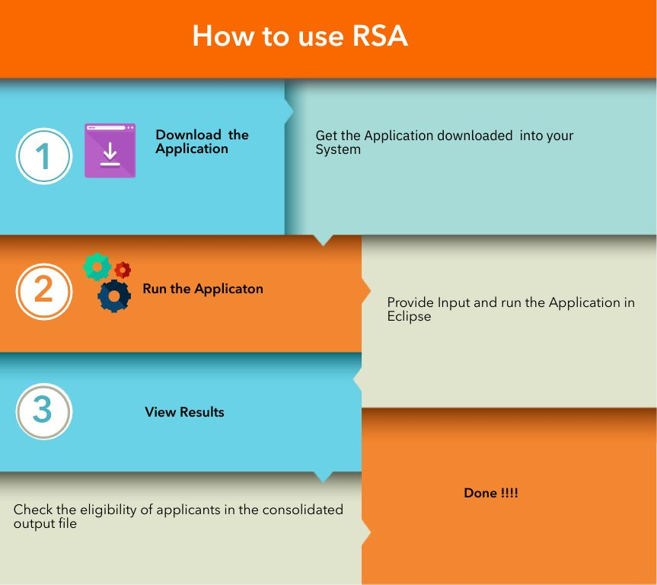

## **Downloading the application**

To start using RSA, download the application files into your system.

**Prerequisites**

Before downloading the RSA application, you must:

Have GIT and Java IDE – Eclipse installed.

Have access to Externship Sag/RSAteam1 repository in GITHUB.

**To Download the RSA application**

1. Open the GIT CMD prompt, using the command **CD** go to the folder where you want the application files to be downloaded.
2. Enter the below command to get the application files into your local system

**GIT clone** [**https://github.com/externship-sag/resumeScreening.git**](https://github.com/externship-sag/RSATeam1.git)

1. Open Eclipse, navigate to the File menu and choose

**FILE** 🡪 **Open projects from the file system**

1. Click **Directory** and choose the folder where the RSA files are downloaded on your computer.
2. Click **Finish**

Now the application is available on your computer and ready to use.

## **Running the Application**

To start screening the resumes, the RSA application must be run in Java IDE- eclipse.

Follow thesteps to input resumes, enter screening criteria, and start the execution of the application.

**Prerequisites**

To start the execution of RSA, you must open the downloaded application files in eclipse.

**To execute the RSA application**

**Note:** The application can process resumes only in pdf,.doc, .docx, and .txt format.

1. In Eclipse, expand and browse the folder under **ResumeScreeningApp**.
2. In the **data** folder, the **RSAConfig.xml** file lists the screening criteria, modify this list as per the your need.
3. Copy all the applicant’s resumes to be screened into the **data\resume** folder

4. Select the **ResumeScreeningApp** ,go to the **Run** menu, and choose

**Run** 🡪 **Run** **as🡪** **Java Application**

5**.**  You will get a list of Java Application, Choose **ResumeScreeningApp-com.rsa** from the list.

The application starts running.You will be notified with a message in the Eclipse console at the start of the application.

## **Viewing results in the Application**

You can view the results of screening in a CSV file generated with the applicant’s details.

**Prerequisites**

Before viewing the results, verify the messages in the eclipse console and make sure the application run completed successfully.

**Viewing the results after the run**

1. In Eclipse, Choose the **ResumeScreeningApp-com.rsa** and open the **data\output** folder.
2. In the **output** folder, RSA creates a **Results.csv** file with the results of the application.
3. The **Results.csv** file will list all the applicants processed by the application with their basic information, for each applicant the **Eligible Column** in the **Results.csv** file will tell you if they have met screening criteria or not**.** If the applicant meets the screening criteria, this column has a **YES** else a **NO** for non-eligible applicants.

RSA gives you messages in the Eclipse console, making it easier to know the status of processing in the application. You will be given messages at the start and completion of the Application. RSA will also give you the name of the resume currently processing or skipped due to invalid format.